Adding a wishbone module

This is a continuation on the Papilio Quick Start Guide. It uses many of the files created in the tutorial as well as two files that will be provided separately for interfacing with a quadrature decoder.

For this guide you will need the wb_quad_decoder.vhd and quad_decoder.vhd files. Please move these into the Tutorial directory before we begin.

Step 1 – Adding the vhd files

To start, navigate to the files tab on the left half of the ISE Project Navigator window and click the button towards the top left that looks like a piece of paper with a white plus in a green circle. This is the add files button.
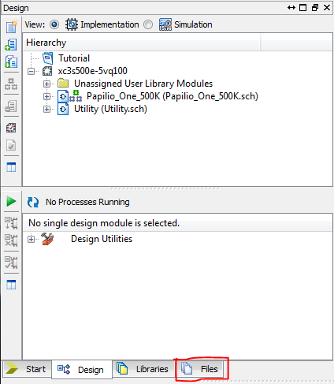
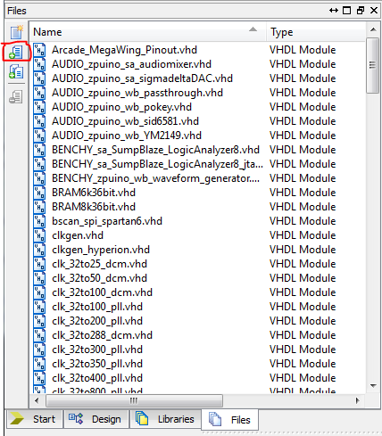
A window labeled Add Source will pop up. Navigate to the folder where you placed the two files and select them both by holding the Ctrl key and clicking them one at a time, and then click Open.

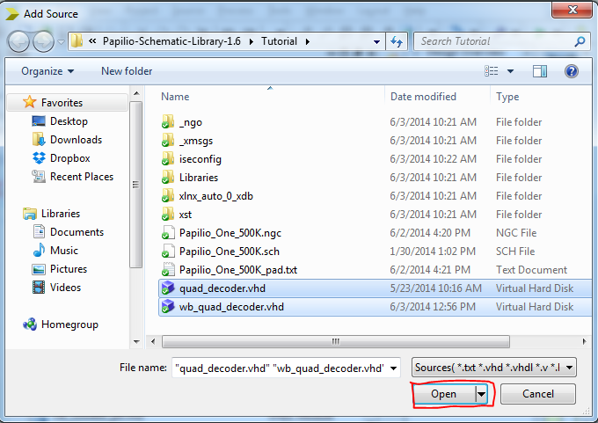
A window labeled Adding Source Files... will pop up with check marks next to the two files you loaded in. Click OK to continue.
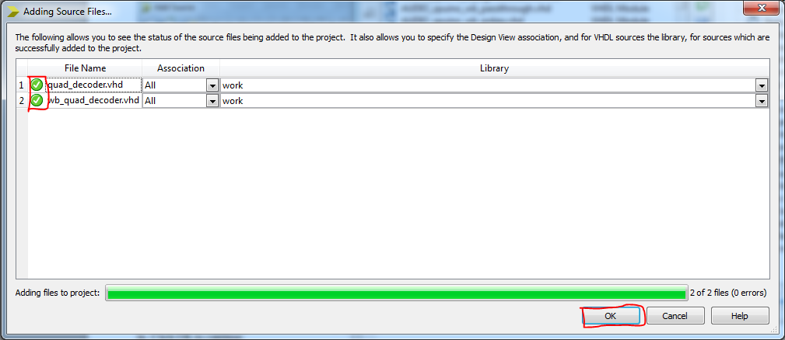
You have now added the .vhd files to the project.

Step 2 – Creating the schematic file

Now that we have imported these vhdl files we need to generate a schematic file for wb_quad_decoder.vhd. Please note that while we are able to redraw the schematic file once it has been generated it is time consuming and is not necessary for more basic vhdl programs.

Now that we have our .vhd files we need to navigate back to the design tab and click on wb_quad_decoder in the hierarchy box, and then expand the box next to Design Utilities at the bottom by clicking the + box.
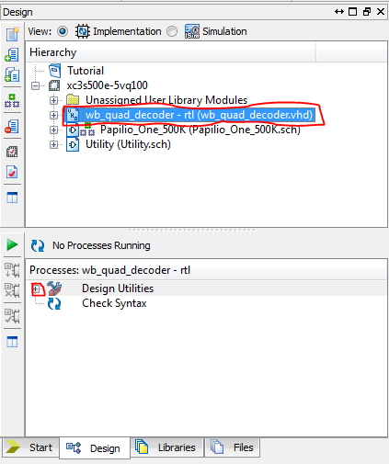
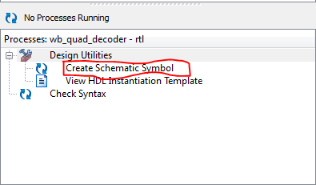
Once we expand Design Utilities we need to double click Create Schematic symbol.
This will run a process to create a schematic symbol for us to use in the project. When it is done running it will show the following in the Console:
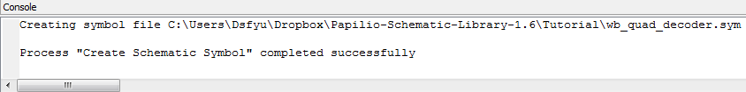
Part 3 – Placing and connecting the new symbols

Now that we have the schematic symbol created we need to open the ZPUino schematic by double clicking Papilio_One_500k under the Hierarchy so we can add the schematic we just created.
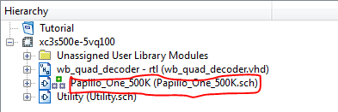
Now that we have opened the Papilio schematic we need to zoom in to the first two wishbone slots. We can do this by holding control while clicking above and to the left of it and dragging the mouse down and right until the whole area we want to work with is selected in the box.
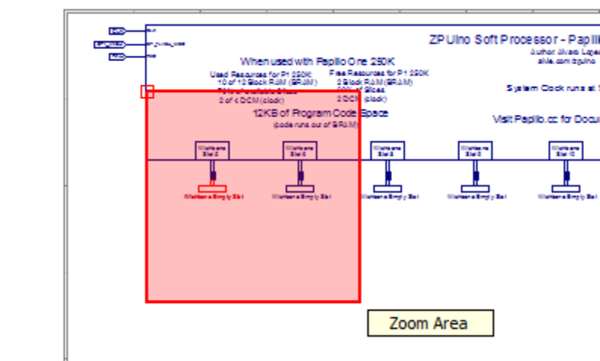
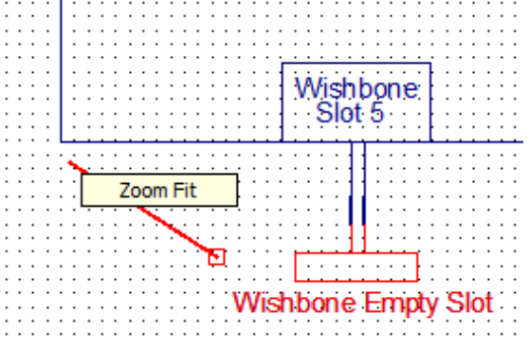
Similarly, we can zoom out by holding control and clicking anywhere on the page and dragging the mouse diagonally up and left before releasing the button.

We need to remove the first two Wishbone Empty Slots from the project to make space for our decoders. We can do this by highlighting them or clicking them individually and hitting the delete key. Alternatively, you can right click on them and select delete from the drop-down menu that appears.

Now that we have removed the Wishbone Empty Slots we can add our new encoder symbols.

Navigate to the Symbols tab at the bottom left.
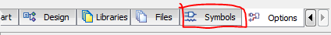
Now that we have the Symbols tab open we need to scroll through the Categories box until we see the file location we loaded our vhdl files from. Click the file path and it should display the name of the vhdl file we created the schematic for in the Symbols box.

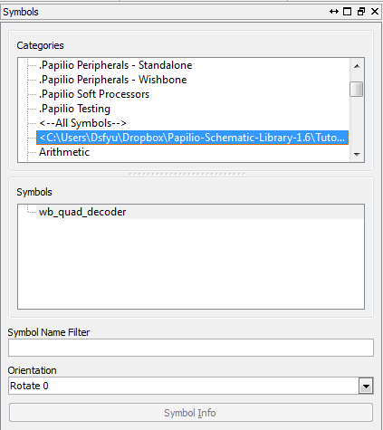

Double click the wb_quad_decoder option in symbols and click on some blank space on the schematic to place the symbol. Do this a second time for the module so we have two of them to connect.

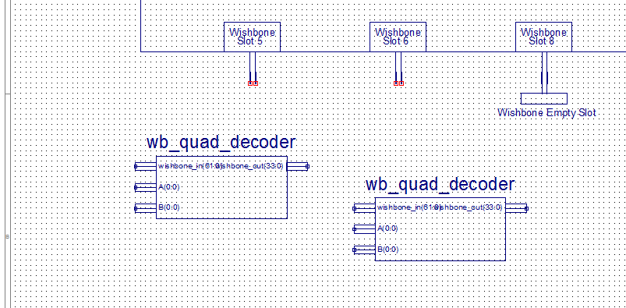
Note that these do not look like typical wishbone modules since we haven't edited the automatically generated schematic.

Now that we have the quad decoders added we need to add IO markers.
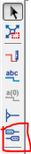
We can add IO markers by clicking the button in on the bar to the left of the schematic that shows two boxes with wires coming from them and then clicking the squares at the end of the connections from the wb_quad_decoder modules.
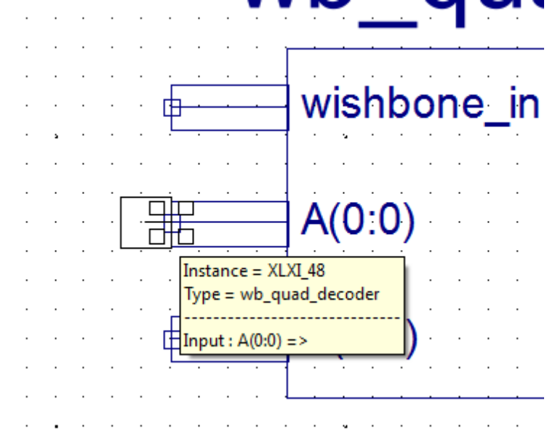
Repeat this for the A and B connections on both modules.

Now that we have made the A and B connections we need to connect the modules using the Add Wire button. This button looks like a pen drawing a red line and can be found to the left of the schematic.

To make connections we just need to click the net on the module and then the left net from the wishbone bus as shown below.
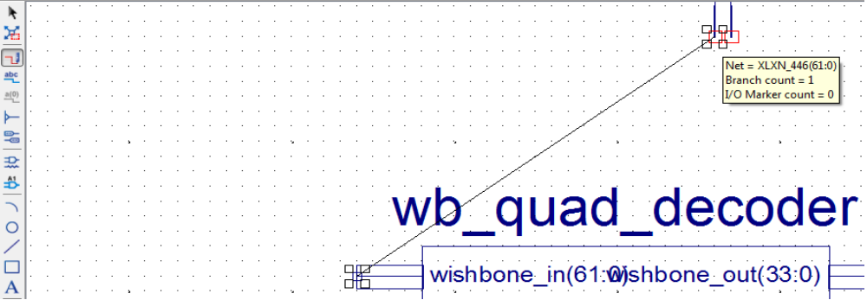
Repeat this by connecting the wishbone_in nets to the left nets of the wishbone slots, and the wishbone_out nets to the right nets of the wishbone slots. The project navigator will automatically route the connections, but you can drag and drop them with the mouse option to move them as you see fit.

Now that we have our modules placed and connected they should look something like this:
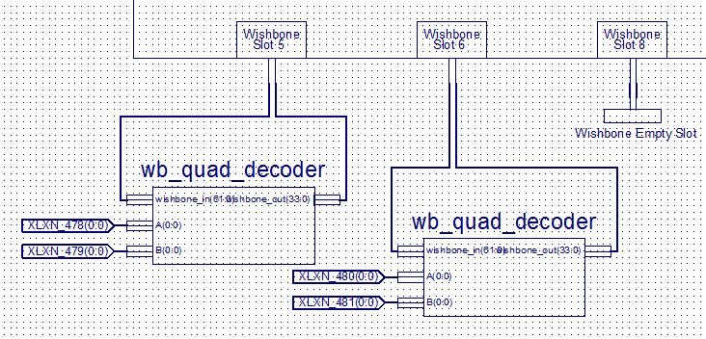
To make these IO markers connect to physical pins on the Papilio board we need to remove the existing IO markers and nets for the pins we want to connect to. For the purposes of this tutorial we want to connect to pins 3 and 4 for the first module and 5 and 6 for the second module.

To delete the nets we need to move to the wings at the bottom right of the schematic. We will be removing the nets and markers for WING_CL3,4,5,and 6 as designated below.
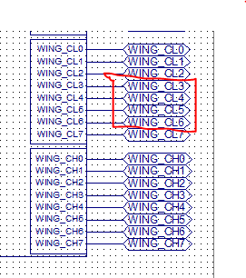
To actually delete the nets and markers we can select them by clicking on them or clicking and dragging on the whole area around them. When you select the whole area it is very easy to accidentally select an unintended component or miss the components you are trying to select. Because of this we will individually select the nets and markers to delete them. Once that is done it should look like this:
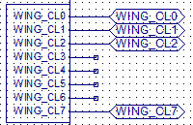
Now that we have deleted the nets for those pins we need to rename the new nets attached to the module with the Add Net Name button.
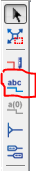

Once we click the Add Net Name button a new Add Net Name Options field will appear to the left. We need to enter the name of our first net name in the Name field and select Increase the name so the numbers on each net we place will increment.
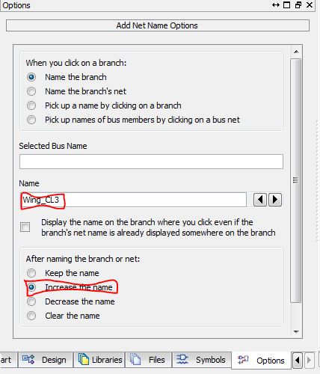
Once we set these options we need to click the nets one at a time to set A to CL3 and B to CL4 on the first module and set A to CL5 and B to CL6 on the second module.
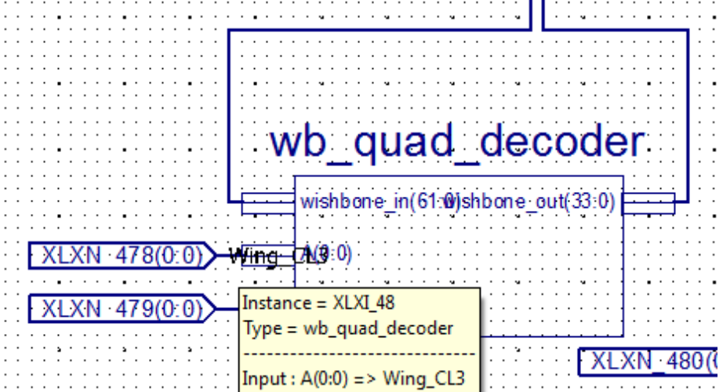
Once we are done setting net names it should look like this:
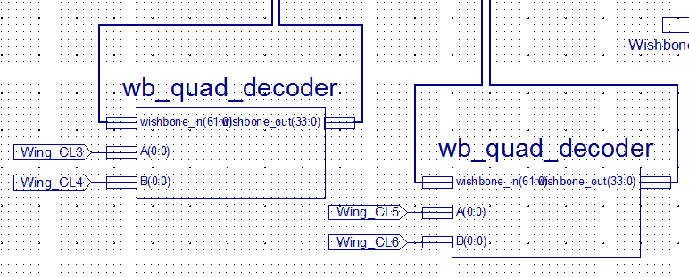
Now that the nets have been renamed we have finished adding the new modules to the schematic and it is ready to generate a bit file.

Part 4 – Programming the Papilio

Now that we have finished the project we need to generate the bit file and flash the papilio as explained in the previous tutorial.

For this tutorial we will be writing the following example code on the ZPUino to display the outputs from the decoder. Attach the encoder outputs to pins 3 and 4 for the first encoder and pins 5 and 6 for the second encoder.

#define input1 (IO_SLOT (5)) //read inputs from wishbone slot 5
#define myreg1(x) REGISTER(input1,x) //set the inputs to a register

#define input2 (IO_SLOT (6)) //read inputs from wishbone slot 6
#define myreg2(x) REGISTER(input2,x) //set the inputs to a register

long count1, count2;

void setup() {
Serial.begin(9600);
myreg1(0) = 0x00000000; //set the registers to zero during initialization
myreg2(0) = 0x00000000;
}

void loop() {
delay(60);
count1 = (long)myreg1(0);
count2 = (long)myreg2(0);
Serial.print("Encoder 1 value: ");
Serial.println(count1);
Serial.print("Encoder 2 value: ");
Serial.println(count2);
Serial.println("");

}

This code will read the encoder counter values from the wishbone buses and output it over serial every 60 milliseconds.

Once you have uploaded this code to the papilio press Ctrl+Shift+M to open the serial monitor. Try turning the first and second encoder left and right and watch the values over the serial as then increment and decrement from turning the encoders.

Congratulations! You have added two decoders to the ZPUino soft processor and have read the value through code on the ZPUino!

